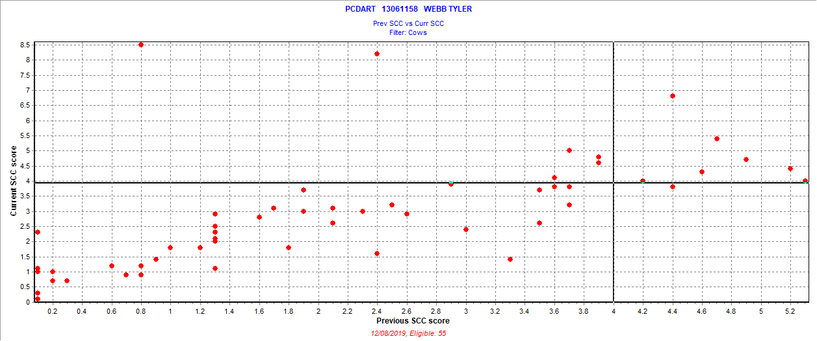

November 22, 2019 test date

New = 7 = 12.7%

Chronic = 7 = 12.7%

Cure = 1 = 1.8%

Uninfected = 40 = 72.7%

Also 0 fresh cows SCC > 3.9 – seasonal herd